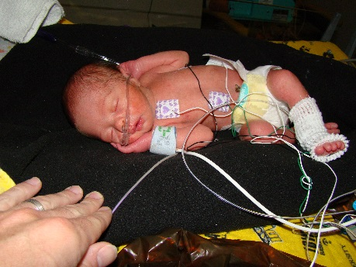

Meet the Jess Family

My first pregnancy in February of 2010 started as high-risk from the very beginning due to unexplained complications and bleeding. We were thrilled at 22 weeks gestation to find out we were expecting a baby boy. That joy was short-lived though, as the ultrasound also showed a cyst on our son’s brain. We were referred to the University of Iowa Hospitals and Clinics for further testing and observation, and the doctors indicated that our baby boy had Dandy Walker’s Syndrome. This rare, congenital brain malformation involves the cerebellum and the fluid spaces around it. The syndrome can result in slower motor development, progressive skull enlargement, seizure, lack of coordination, nerve issues in the eyes, face, and neck, and also abnormal breathing patterns. We were faced with the fifty-fifty chance that our baby could have either serious developmental issues, or he could have minimal to no issues. We were left to wait until his birth to find out the extent of his birth defect.

On September 11, 2010, our miracle baby boy Bennett Thomas was born seven weeks premature, weighing four pounds, two ounces. He was rushed to the NICU to be stabilized after delivery. On day two of life, Bennett underwent a MRI, and the doctors determined that he had the Dandy Walker Variant. This is less severe than the syndrome itself and therefore and they didn’t believe that he would have any developmental challenges. While this news was reassuring and joyful, Bennett still struggled with side effects of his prematurity including jaundice, apnea spells, feeding issues, and weight gain. We spent a total of five weeks in the NICU in Iowa City until Bennett was discharged on October 16, 2010 with home oxygen and an apnea monitor.

My second pregnancy was picture-perfect in comparison. I received weekly progesterone shots to prevent preterm labor, and it resulted in a picture-perfect experience with the birth of our second son Brady Steven on March 8, 2013.

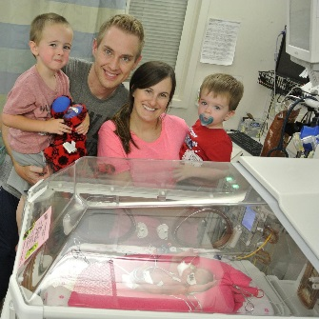While hoping for a repeat experience with my third pregnancy, we were scared and worried when this pregnancy also became very high-risk. At 18 weeks gestation my cervix was thinning, and was only half the thickness it should have been. I also was having some unexplained bleeding. The doctors found that our baby girl had two markers for Downs Syndrome. They were unsure about advising for me to receive a cerclage, as the bleeding and thin cervix could have been indicators that our baby was very sick and that my body was trying to end the pregnancy. However, Chris and I were determined to do anything possible for our baby girl, and went ahead with the cerclage. After ten weeks of bed-rest, I started having some pressure and contractions at 27 ½ weeks. I was given magnesium sulfate to help minimize the contractions, as well as two steroid injections, to accelerate the development of our baby girl’s lungs. This would help give her breathing a better start after delivery. At 28 weeks gestation, Brynn Marie was born on July 28th at 2:18am, weighing two pounds, four ounces. She was airlifted to the NICU in Iowa City a short time later. During her twelve week hospital stay she had multiple head and kidney ultrasounds, heart echoes, chest x-rays, and eye exams. Her fragile body underwent many PICC lines, blood draws, IVs in her arms, feet and head, and two blood transfusions. She also overcame a heart PDA, jaundice, apnea spells, high blood pressure, two infections, and feeding difficulties. We were so grateful when Brynn was discharged home to her two brothers on October 14, 2014.

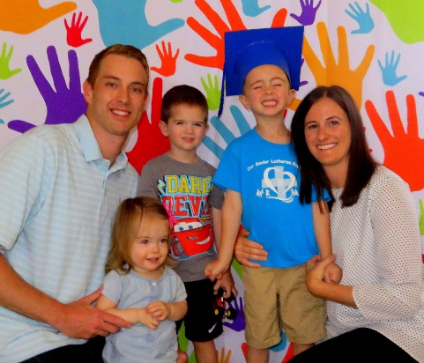Today, our family has grown leaps and bounds since those scary moments. Bennett is a happy, healthy and energetic boy who will be 6 in the fall and headed off to kindergarten. Brynn’s development is on track for her adjusted age. She has continued to be followed by Iowa City’s High Risk Department, as well as the Area Education Agency’s physical therapist. While we are unsure what may lie ahead for Bennett or Brynn as they advance into their school years, we know that the same fighting spirits they had in the NICU will help them face any obstacle that comes their way.

We are honored to be serving as the 2016 Signature Chefs Auction Ambassador Family, and to be giving back to an organization whose mission is inspired by all babies, those born healthy like our son Brady, and those who need help to survive and thrive like Bennett and Brynn. The research conducted via the March of Dimes has impacted our lives so much, and we know that together we can make a difference to other families just like ours.

~Erika & Chris, Bennett, Brady, and Brynn Jess